

**SYSTEM OVERVIEW**

*Sample Text here sample text here sample text here sample text here sample text here sample text here sample text here sample text here sample text here sample text here sample text here sample text here sample text here sample text here sample text here sample text here sample text here sample text here sample text here sample text here sample text here sample text here sample text here sample text here sample text here sample text here sample text here sample text here sample text here sample text here sample text here sample text here sample text here sample text here sample text here sample text here sample text here sample text here sample text here sample text here sample text here.*

**GENERAL INFORMATION OF SYSTEM**

*Sample Text here sample text here sample text here sample text here sample text here sample text here sample text here sample text here sample text here sample text here sample text here sample text here sample text here sample text here sample text here sample text here sample text here sample text here sample text here sample text here sample text here sample text here sample text here sample text here sample text here sample text here sample text here sample text here sample text here sample text here sample text here sample text here sample text here sample text here sample text here sample text here sample text here sample text here sample text here sample text here sample text here.*

**SYSTEM PREFACE**

*Sample Text here sample text here sample text here sample text here sample text here sample text here sample text here sample text here sample text here sample text here sample text here sample text here sample text here sample text here sample text here sample text here sample text here sample text here sample text here sample text here sample text here sample text here sample text here sample text here sample text here sample text here sample text here sample text here sample text here sample text here sample text here sample text here sample text here sample text here sample text here sample text here sample text here sample text here sample text here sample text here sample text here.*

**User Manual - Property**

**CEU Purchasing System**

Property Dashboard

*Figure 1.0 – Top Navigaton*

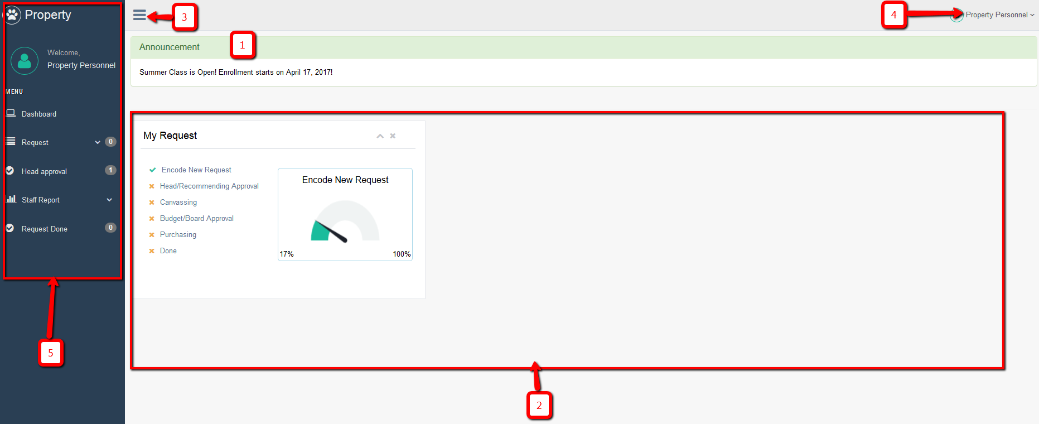

1. Announcement area.
2. It shows all your current request showing its level of progress.
3. Hide/Show side bar menu
4. Top navigation
   1. Settings
   2. Help
   3. Logout
5. Side bar menu

**Request**

Note: There you can see the number at the right side of the menu. That means that you have a number of tasks for that menu and you need to take action. Also note the every list or table of that page where you can see the green row, which means that you need to take action on that row.

* 1. Staff Requests – This page where you can see all of the request of your staff.
  2. My Requests – This page where you can see your request only. You can view the items by clicking the “View Items” button. You can print your request and got to the details of your request just by clicking the link in the request name. You can also edit your request by clicking the “Edit” button.
  3. Request New – This menu is the step where you can request.

**Head Approval**

* This menu or page will appear only if you have assigned by the admin as a head of the department. There you can see the newly requested by your staff or even other department staff if it is assigned to you as a recommending approval.
* The buttons under “Action” button will be different depends on the current status of the request.
* Click the “View Items” button to view the items that is assigned to you. See figure 3.1. You can also see the items that is assigned to the other head (see *Assigned To* column). You can approve and deny only the item assigned to you. When you deny, it will notify the requisitioner. Once the requisitioner will response, it will appear the response to the *Requisitioner Note* column. All the items should be approved by all the recommending officer before it will be forwarded to the admin.

**Staff Reports**

* All the reports here is only for your staff. This menu will appear only if you are the head of the department.

1. Request Reports – There you can see on this page all the request report of your staff. There are different filter like Year, Month and School Year. You can print it as PDF, Excel or print it directly.
2. Item Reports – There you can see all the items requested by your staff. There are different filter like Year, Month and School Year. You can print it as PDF, Excel or print it directly.
3. PO Reports – There you can see all the Purchase Order Approved under your staff. There are different filter like Year, Month and School Year. You can print it as PDF, Excel or print it directly.

**Request Done**

* You can see on this page all the request that is done, being delivered or it is already delivered. You can update the status when it is delivered to the inventory. You can view the item of each PO by clicking “View Items” button.